SESSION 15: R FOR BUSINESS ANALYTICS

Assignment 1 Data Analytics

2 Table of Contents

1. Introduction .......................................................................................................................................... 3

2. Objective ............................................................................................................................................... 3

3. Prerequisites ......................................................................................................................................... 3

4. Associated Data Files ............................................................................................................................ 3

5. Problem Statement ............................................................................................................................... 3

6. Expected Output ................................................................................................................................... 3

7. Approximate Time to Complete Task ................................................................................................... 3 Data Analytics

3 **. Introduction**

This assignment will help you understand the concepts learnt in the session.

**2. Objective**

To understand the concepts in R.

**3. Prerequisites**

Not applicable.

**4. Associated Data Files**

N/A

**5. Problem Statement**

Here is a table with 6 rows and 3 Columns :

X Y Z

910 a1 b1 820 a2 b2 730 a3 b3 640 a4 b4

550 a5 b5

460 a6 b6

Put the data in .xlsx, .txt , .csv and read it using R Code.

Solutions:

Please find the screen shot of queries below

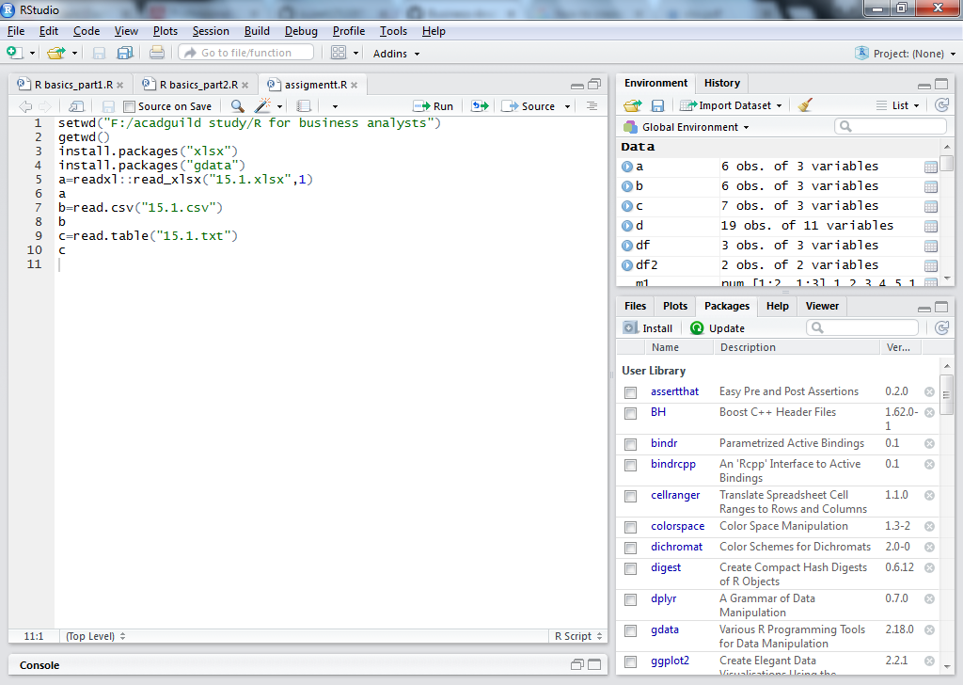

Please find the screen shot of result below

